Education 20/20 Inc.

Education 20/20 Inc. is an independent, broad based, national, not-for-profit education organization, located in Charlottetown, PEI and is governed by a volunteer Board of Directors.

Vision: A quality education for every Canadian.

Mission: To support and strengthen a culture of learning for all Canadians.

Mandate: To contribute to the education of our citizens by providing information, encouragement and support for a quality education for all citizens.

Activities:
- Education Award,
- Monthly electronic newsletter. Website, Occasional papers,
- Research, consultation. workshops
Directors:
- Don Glendenning, President
- Bill Whelan, Vice President
- Tom White-Hassler
- Katherine McQuaid
- Donald DesRoches
- Amber Jadis
- Tess Miller
- Ronnie McIntosh
- Ross Reid

Pub/Bro/Frame/12


AN
EDUCATION
FRAMEWORK

Education 20/20 Inc.
101 Kent St., PO Box 624/rue Kent, BP 624
Charlottetown, PEI C1A 1M0 Canada
Tel: 902-892-2060
CONTENTS
- Learner
- Road of life
- Education
- Principles
- Learning
- Teaching
- Functions
- A Call to Action
- Quality
- Rating scale
- Learning path
- Levels
THIS BOOKLET
Writing is part of my learning style, the information in this booklet therefore ws pulled together as part of my search for understanding of Canadas education system. Only after benfitting from it myself did I think that it amy also have value for others.

There is a shortage of current and independent information about education in the public domain; there is also a lack of debate especially between those who provide educational services and those who use them. This booklet attempts to:
- Respond to questions and conversations with Islanders with an interest and concern about the community in which we live and work
- Provide a framework for asking questions and making decisions about educational matters in your school district.
- Provide a ready reference to current information and thinking on the subject
- Provoke debate about education within the community at large and with educators
OUR THANKS TO:
• Louise Carota for her rendition of the road of life
• Cozy for layout and editing
• Sponsors
- Editor

FURTHER INFORMATION
- Adams, Robert E, Lance Hong and Luke Steinke, DACUM: The Seminal Book,
- Hall, Dr. Tom and Don Glendenning, The Canadian Restructured School Plan, (CRSP)
- Aitken, William, The Story of the Eight Year Study,
- Fadulu, Lolade, “Why is the US so Bad at Worker Retraining”, Atlantic, January 4, 2018

INNOVATION IN ACTION
- Differentiated Staffing- Bishop Carrol High School, Calgary
- Blended learning - Sail Academy, BC
- Full Service schools, Toronto
- individually designrd schedules - Jason Lee Middle School, Tacoma, Washington –
- Democratic management Hanover, New Hampshire –
- Principals Project, Chicago Principals Research

QUALITY EDUCATION
A quality education is one where:
- The support services are focused on learners and learning.
- Information and advice is both timely and independent.
- Teachers are professional, autonomous and accountable
- Achievement is a constant and time the variable

TYPES OF ASSESSMENT
Types of Student assessment
While searching for information on grades and grading, I came across an item by Robert Paul Wolff (Wolff: A discourse on Grading, 1969) in which he identified three purposes for assessing students:

Criticism or analysis, formative which is for the purpose of designing additional strategies for the purpose of helping a learner learn. Criticism prepares a teacher to provide meaningful feedback and is part of the ongoing give and take of the learning process.

Evaluation is designed to establish a person’s level in a subject or field and should be criterion referenced

Ranking intended to show how one stacks up against others; ranking results in students being winners or losers as for ranking, schools could take a lesson from sports with both coaches and referees. Ranking results from competitions; students should be encouraged to participate and teachers and students can use the results but teachers should play no part in the ranking process.

LEARNING PATH
The larning path below was developed in consultation with a panel of p0osttsecondary students who talked about their learning experience. The path shown below results from that discussion and depicts the flow of learning experienes.

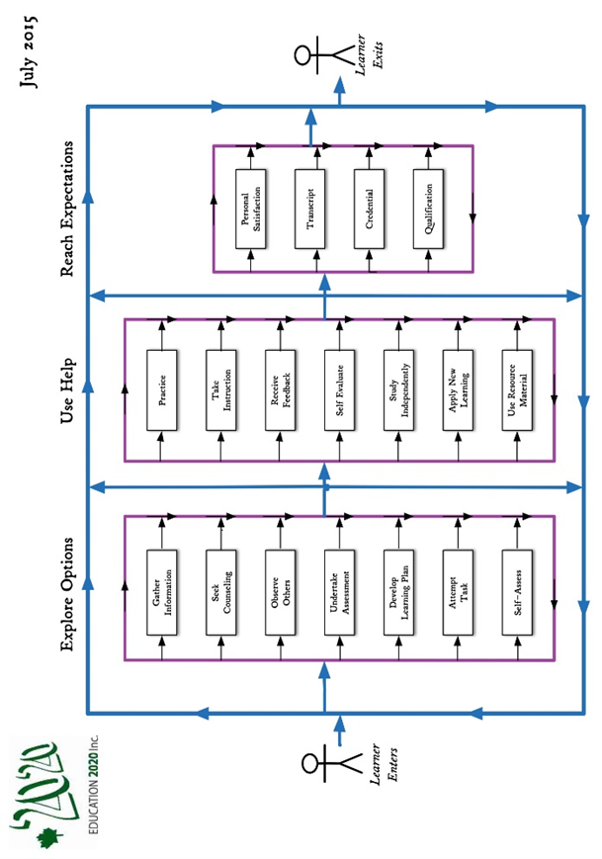

THE LEARNER

A learner is a person who, for whatever reason, is trying to bring about change in his/her life - trying to change an attitude, gain new knowledge or add to one’s skills. But learners are neither empty jars nor blank slates; each learner carries three pieces of luggage to every new learning situation:
- Certain physical, mental and emotional conditions with which the learn was born.
- Prior learning resulting from formal study, home circumstances, travel, state of health, personal interests, culture in which they operate and learning styles
- Aspirations and imagined future including where one will live, the work one will do and the lifestyle one will have, the nature of the family, quality of life, etc.

Our future may require a different mix of attitudes, skills and knowledge than the ones we now have; the process of developing the new mix is called learning; the discernable change that occurs in us as a result of learning is education, and people who help us learn are usually called parents, or if paid, will likely be called teachers

Most of us need help in at least some of our new learning experiences; students tell us that they sometimes need:
- Information: recent, independent, reliable, timely
- Presentation: tutoring, demonstrations, discussion and debate
- Feedback: effective, valid, transparent, relevant
- Counselling: planning, coaching,
- Opportunity: access, time, funding, transportation
- Products and technologies: textbooks, references, self-instructional material and assistive technologies

EDUCATIONAL BELIEFS
One gains an education through learning; education is the result of any learning experience that has a formative effect on the way a person thinks, feels or acts. Below are a number of beliefs that shape one’s views of education:
- All people can learn but some may need more time and assistance than others.
- Learning is an individual matter but may occur in a group setting.
- The most important part of one’s education is the part that occurs in the first six years of life.
- The purpose of education is to help a person gain attitudes, skills and knowledge that will serve them well for the remainder of their life’s journey.
- The responsibility for one’s education rests with one’s parents and/or one’s self.
- Our future as a community depends, in a large measure, on the nature and level of education of our citizens.
- Government’s role is (1) to encourage education among its citizens, (2) to ensure equity in its support and (3) to ensure the existence of skilled workers for the future of the community it serves.
- An education system should be designed to deliver educational services needed by its citizens to the extent possible if, as and when needed.

DYNAMIC RATING SCALE

Skill-based curriculum demands criterion referenced assessment; one such rating scale appears below.

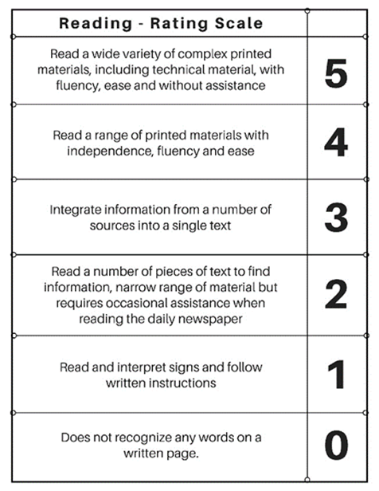

Benchmark
A level of performance which is widely recognized by practitioners and the public atlarge and serves as a rwference against which others are judged. A person could demonstrate a “3” on the scale above, by carrying on a conversation about items in the morning paper conversation .
NOTES ON QUALITY

Much has been written about improving the quality of Education;selected reference include:

UNICEF, The International Working Goup on Education, Florence, Italy, 2000
A quality education system is one where:
- learners are healthy
- Environments are safe and respectful
- Content is relevant
- Outcomes are linked to personal and community objectives
- Support is focused on learners and learning.
- Information and advice is timely and independent
- Teachers are professional, autonomous and accountable

OECD, PISA in Focus, OECD, 2011 studied PISA results in 13 countries and concluded that “in countries where schools have greater autonomy” over what is taught and how students are assessed, students tend to perform better”.

MEI, (2015) an Educational Think Tank in Quebec concluded that “accountability and autonomy” jointly applied, are key factors in school achievement”. He goes on to say that that “changes to accountability and autonomy would cost government nothing, would entail better academic results and allow education to better adapt to the diversity of student needs and aptitudes”

A CALL FOR ACTION

On April 9, 2015, in the midst of a Provincial election, Education 20/20 Inc. issued this Call for Action.

- A “clear and compelling” vision of education for all Islanders. We believe that having such a statement is required, especially for a service as large and complex as education

- A learner centered service model that provides support in all domains to learners if, as, when and where needed. Doing so would involve student centered outcomes, criterion referenced assessment, flexible scheduling, challenge for credit arrangements, and greater autonomy and accountability for teachers.

- Leadership in the creation of a learning culture and providing a quality education for every Islander. Government should focus on matters of planning, setting priorities, funding, monitoring, and quality control, ensuring the availability of professional resources, home sup-port for preschool children, information and continuing education.

- Autonomy for schools in their day to day decision-making

- An independent qualification body for the purpose certifying individual levels of achievement for persons wanting or needing such documentation.

- A service delivery model where professionals are directly accountable to clients for the nature, extent and quality of service provided

- Put in place an externally controlled strategy to encourage and support innovation.

ROAD OF LIFE

The road is a metaphor for the experiences one encounters between birth and death. The literature suggests that each person fills a number of roles, that of an individual, family member, citizen, learner, producer and consumer – a challenging road to say the least.

While each reader could make their own list of essential skills, I suggest that most would likely include the following:

- Literacy
- Numeracy
- Community awareness
- Self-management
- Interpersonal reltionships
- Information technology
- Everyday Science

FUNCTIONS OF AN EDUCATION SYSTEM

Public education in Canada is a provincial responsibility; education for employment, especially for adults however is usually considered a federal matter. A system for delivering educational services would normally include the following components:

- Governance: leadership, planning and reseach
- Instruction: presentations, practice, diagnosis and access
- Quality assurance: evaluation, certification and qualifications
- Products and Technology: textbooks, Wi-Fi, hardware, MOOCS, facilities, self-instructional materials and software
- Information Counselling: information and counselling, promotion and advocacy
- Funding: tuition, facilities, access,

When designing an education system, for each service to be offered, planners would be expected to:
- Describe its the nature and importance
- Estent to which it is needed and by which citizens
- Degree of financial support
- Preferred provider

CURRICULUM

Most curriculum development in Canada is outcome based; our examination, however, suggests that the is of competencies is on the upswing. Competencies we find relate better to student learning, better describe learner expectations, are on dentified significant differences in the the way that outcomes are defined, described and organized. Use every day language, Consider it a survey of the applications of the subjet in eevery day use. Realized thar, using math may be linened to a language. The bilityto manipulate the language rather than the rootss of the language should be a major focus.Furthermore, competencies dedcribe the role o

Among the initial steps, one must include (1) an independently developed master list of skills for each field of study and (2) a common set of community based assessment criteria, The full”subject map” would dramatically increase the ability to communicate in any subject field and , be useful as a both a planning and guidance tool. The development process would naturally include details about the skill in question, typical learning activities, and self assessment guides. Maps will also be useful to plot career path, track progress, self study and self assessmentSee sample rating scale elsewhere in this booklet
ESSENCE OF EDUCATION

Educationmay well be the most important ssue of the day; it will determine, to a large degree,the quality of our individual lives as well as the quality of the community in which we live. Among its meanings we find:
• Education - any experience that has a formative effect the way a person thinks, feels and acts
• Quality education: “one that provides all learners with capabilities they require to be come economically productive, develop sustainable livelihoods, contribute to peaceful and democratic societies and enhance individual well-being”-New Zealand
- Education - a sector of the economy “primarily engaged in providing educational servives” .

- Education - a government department primartly concerned with providing instructions to weople in schools

SCHOOL FUNCTIONS
The list below is taken from my own files and reflects a teacher’s role in an innova-tive school in the year 2020:
• Assist in design of learning pro-grams
• Inform and counsel
• Create and maintain learning envi-ronment
• Evaluate learning resources
1. Assist in and support self learning
• Communicate in learning environ-ment
• Interact with community
• Manage learning,
• Develop and evaluate instructional resources,
• Develop personal competencies
• Perform administrative duties
• Diagnose learning needs

LEVELS OF LEARNING
1 Remembering: Recall previous learned information.
2 Understanding: Comprehending the meaning, translation, interpolation,
and interpretation of instructions and problems. State a problem in one's own words.
3 Applying: Use a concept in a new situation or unprompted use of an abstraction. Applies what was learned in the classroom into novel situations in the work place.
4 Analyzing: Separates material or concepts into component parts so that its organizational structure may be understood. Distinguishes between facts and inferences.
5 Evaluating: Make judgments about the value of ideas or materials.
6 Creating: Builds a structure or pattern from diverse elements. Put parts together to form a whole, with emphasis on creating a new meaning or structure.



GOVERNANCE & LEADERSHIP
Leadership
Planning
Liaison
Support
Research
Advocacy
Quality Control
?

INSTRUCTION
Presentation
Demonstration
Practice
Diagnosis
Instructional materials
Liaison
Coaching
Record keeping
Guided Practice
?

QUALITY ASSURANCE
Credential
Qualification
Proficiency
Level
?

TYPICAL
EDUCATION SERVICES


Islanders on the road of life

Education system - services put in place by a community to encourage and support the education of its citizens

INFO & COUNSELLING:
Information
Counselling
Assessment
Diagnosis
Referral
Advocacy
?

HUMAN RESOURCES
Teachers
Administrator
Teacher Advisors
Teaching Assistants
Specialists
Guidance Counsellors
?

LEARNING PRODUCTS
Texts and
References,
Self-instructional material
Assistive technologies
Internet
Software
MOOCS
Technology
?

FUNDING
Capital
Operating
Transportation
?
vis-2

